Parallel Programming Exercise 6 – 8

Author: | 李昌樺 (R11525006@ntu.edu.tw)
Student ID | R11525006
Department | Engineering Science and Ocean Engineering
(If you and your team member contribute equally, you can use (co-first author), after each name.)

Problem and Proposed Approach
(Brief your problem, and give your idea or concept of how you design your program.)
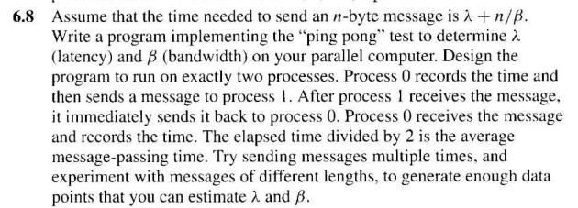

- 初始化mpi環境 => 處理器id=rank , 處理器總數=psize
- 為得到λ與β的值，創造 [A]*{x}={b}的環境，另λ與1/β分別為x1與x2
- {b} -> b1為T1 ,b2為T2 ，T1與T2為兩次不同的溝通時間
| 1 n1 |
- [A]= | | ,n1、n2分別為兩次溝通之前所傳送的byte數
| 1 n2 |
- Rank0傳送給rank1一個4byte的整數，而rank1接收後立刻將其回傳，重複執行10000次
並記錄其時間time1
- Rank0傳送給rank1一串包含10000個4byte的整數列，而rank1接收後立刻將其回傳，重複執行10000次並記錄其時間time2
- 將 time1 與 time2 取平均 (i.e. time/(10000*2))，放入{b}中
- 計算[A]的反矩陣[A]⁻¹
- 透過矩陣乘法 {x}={b}*[A]⁻¹求出λ與1/β
- 將1/β轉換成β

Conclusion and Discussion
(Discuss the following issues of your program)
- How can you improve your program further more?
看到題目的第一個想法就是以這種形式下手，感覺過程有點複雜化了，或許會有更快速且準確簡單的方法可以改良。
- How does the communication and cache affect the performance of your program?
減少溝通的次數則可以省去latency所帶來的效能延遲，所以在bandwidth足夠的情況下，應該多以陣列的方式一次傳送多個訊息。

Appendix(optional):
(If something else you want to append in this file, like picture of life game)
使用fortran90所寫的程式
module load mpi/openmpi-3.0.0/gcc485
mpif90 –o 6.8 6.8.f90
qsub 6.8.sh !!!(sh檔是用textbook所寫，需先將dos轉為unix)

程式執行結果:
